--- TOP 10 FEATURE & METADATA COMBINATIONS ---

 | Text Strategy | Model | Metadata Combination | R2-Score | RMSE
423 | Semantic Only | Gradient Boost | Effective_Experience_Years + Experience_Penalt... | 0.3202 | 0.1291
487 | Semantic Only | Gradient Boost | Effective_Experience_Years + Experience_Penalt... | 0.3154 | 0.1296
247 | Semantic Only | Gradient Boost | Effective_Experience_Years + Experience_Penalt... | 0.3072 | 0.1304
311 | Semantic Only | Gradient Boost | Effective_Experience_Years + Cosine_Objective_... | 0.3045 | 0.1306
295 | Semantic Only | Gradient Boost | Effective_Experience_Years + Cosine_Objective_... | 0.3013 | 0.1309
455 | Semantic Only | Gradient Boost | Effective_Experience_Years + Cosine_Objective_... | 0.2990 | 0.1311
103 | Semantic Only | Gradient Boost | Effective_Experience_Years + Cosine_Objective_Fit | 0.2968 | 0.1313
107 | Hybrid (1D OLS) | Gradient Boost | Effective_Experience_Years + Cosine_Objective_Fit | 0.2936 | 0.1316
407 | Semantic Only | Gradient Boost | Effective_Experience_Years + Experience_Penalt... | 0.2927 | 0.1317
427 | Hybrid (1D OLS) | Gradient Boost | Effective_Experience_Years + Experience_Penalt... | 0.2895 | 0.1320
251 | Hybrid (1D OLS) | Gradient Boost | Effective_Experience_Years + Experience_Penalt... | 0.2871 | 0.1322
315 | Hybrid (1D OLS) | Gradient Boost | Effective_Experience_Years + Cosine_Objective_... | 0.2819 | 0.1327
468 | Semantic Only | Linear Regression | Experience_Penalty + Cosine_Objective_Fit + Se... | 0.2744 | 0.1334
469 | Semantic Only | Ridge Regression | Experience_Penalty + Cosine_Objective_Fit + Se... | 0.2744 | 0.1334
420 | Semantic Only | Linear Regression | Effective_Experience_Years + Experience_Penalt... | 0.2735 | 0.1335
421 | Semantic Only | Ridge Regression | Effective_Experience_Years + Experience_Penalt... | 0.2735 | 0.1335
299 | Hybrid (1D OLS) | Gradient Boost | Effective_Experience_Years + Cosine_Objective_... | 0.2709 | 0.1337
491 | Hybrid (1D OLS) | Gradient Boost | Effective_Experience_Years + Experience_Penalt... | 0.2690 | 0.1339
356 | Semantic Only | Linear Regression | Experience_Penalty + Cosine_Objective_Fit + fl... | 0.2680 | 0.1340
357 | Semantic Only | Ridge Regression | Experience_Penalty + Cosine_Objective_Fit + fl... | 0.2679 | 0.1340
🌟 BEST MODEL: Semantic Only | Gradient Boost | R²: 0.3202 | RMSE: 0.1291
Metadata Features Used: Effective_Experience_Years + Experience_Penalty + Cosine_Objective_Fit + flag_entry_level

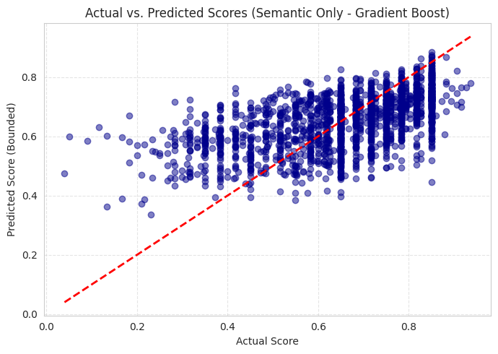

Models trained successfully!

 | Feature Set | Model | R2-Score | RMSE
7 | Semantic Only | Gradient Boost | 0.320212 | 0.129136
11 | Hybrid (1D OLS) | Gradient Boost | 0.289483 | 0.132022
4 | Semantic Only | Linear Regression | 0.273511 | 0.133498
5 | Semantic Only | Ridge Regression | 0.273482 | 0.133500
6 | Semantic Only | Random Forest | 0.249283 | 0.135705
10 | Hybrid (1D OLS) | Random Forest | 0.226491 | 0.137750
8 | Hybrid (1D OLS) | Linear Regression | 0.213539 | 0.138899
9 | Hybrid (1D OLS) | Ridge Regression | 0.213518 | 0.138900
14 | All Text (Optimal) | Random Forest | 0.204031 | 0.139736
15 | All Text (Optimal) | Gradient Boost | 0.168255 | 0.142841
12 | All Text (Optimal) | Linear Regression | 0.158087 | 0.143712
13 | All Text (Optimal) | Ridge Regression | 0.158048 | 0.143715
2 | TF-IDF Only | Random Forest | 0.055248 | 0.152236
0 | TF-IDF Only | Linear Regression | 0.028620 | 0.154367
1 | TF-IDF Only | Ridge Regression | 0.028606 | 0.154368
3 | TF-IDF Only | Gradient Boost | 0.009484 | 0.155880

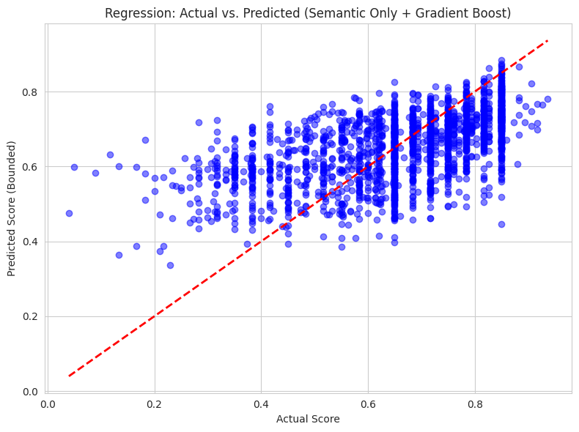

--- Actual vs. Predicted Value Comparison ---

 | Actual Score | Predicted Score | Difference (Predicted - Actual) | Absolute Difference
0 | 0.4167 | 0.6753 | 0.2587 | 0.2587
1 | 0.8500 | 0.7404 | -0.1096 | 0.1096
2 | 0.6267 | 0.6818 | 0.0551 | 0.0551
3 | 0.8500 | 0.7451 | -0.1049 | 0.1049
4 | 0.6500 | 0.6317 | -0.0183 | 0.0183
5 | 0.6500 | 0.5118 | -0.1382 | 0.1382
6 | 0.7500 | 0.6698 | -0.0802 | 0.0802
7 | 0.3833 | 0.6184 | 0.2350 | 0.2350
8 | 0.8500 | 0.7717 | -0.0783 | 0.0783
9 | 0.8167 | 0.6731 | -0.1436 | 0.1436
10 | 0.6233 | 0.5470 | -0.0763 | 0.0763
11 | 0.6500 | 0.5208 | -0.1292 | 0.1292
12 | 0.8500 | 0.7460 | -0.1040 | 0.1040
13 | 0.8500 | 0.7751 | -0.0749 | 0.0749
14 | 0.6500 | 0.5910 | -0.0590 | 0.0590
15 | 0.7600 | 0.7189 | -0.0411 | 0.0411
16 | 0.7367 | 0.5744 | -0.1623 | 0.1623
17 | 0.6233 | 0.5044 | -0.1189 | 0.1189
18 | 0.6567 | 0.5491 | -0.1075 | 0.1075
19 | 0.8500 | 0.7232 | -0.1268 | 0.1268

